The Oscilloscope: Operation and Applications
Instructor: Handong Li
Room7315, No.7 Educational Building, Department of Physics
Introduction
No laboratory, hospital setting, or science fiction film is complete without an oscilloscope. An oscilloscope is essentially an electronic device for making graphs, and is most frequently used for making graphs of rapidly varying phenomena. For an example, an oscilloscope is easily the most useful instrument available for testing circuits because it allows you to see the signals at different points in the circuit. The best way of investigating an electronic system is to monitor signals at the input and output of each system block, checking that each block is operating as expected and is correctly linked to the next. With a little practice, you will be able to find and correct faults quickly and accurately.
- The cathode ray tube (CRT)
The heart of the oscilloscope is the CRT. “Cathode ray” is an historical term for what we now call a beam of electrons. Indeed, it was by fooling around with early cathode ray tubes, then called Crookes’ tubes, that J.J. Thompson in 1897 discovered the particle nature of cathode rays, and called these particles electrons. The general features of a cathode ray tube, which forms the heart of nearly every TV set, are shown schematically in Fig. 1 below.
1
2
3
4
3
4
Filament
cathode
anode
Electron beam
Fig. 1. The structure of a CRT
A fine beam of electrons traveling at an enormous speed (up to 70,000 km per second) is produced by a system consisting of an electron emitting filament (cathode) and a collection of focusing and accelerating electrodes, all collectively referred to as an electron gun. The widened end of the tube opposite the gun is coated with chemicals (phosphors) which glow when struck by the electron beam and produce a bright spot on the screen. The position of the spot is controlled by applying voltage to pairs of horizontal (1, 2) and vertical (3, 4) deflection plates. By simultaneously applying varying voltage to both pairs of plates, the position of the electron-beam spot can be made to trace out a curve on the face of the screen. The deflection of the oscilloscope beam is proportional to the input voltage (after ac or dc coupling). The amount of deflection (Volts/Division) depends upon the setting of the amplitude per division (AMPL/DIV) control for that channel.

- The scanning signal
The main function of an oscilloscope is to show voltage vs time. This is done by applying a ramp (or sawtooth, see fig. 2) waveform into the X-axis (horizaonal) amplifier. During the rising edge of the ramp, the electron beam scans across the screen. When the voltage drops back to 0V, the beam is turned off and quickly goes back to its starting point. This is signified by a thick line when the beam is on and a thin one when it is off (blanked).
U_{x}

t
Fig. 2. Sawtooth waveform

- The trigger
To obtain a stable picture on the CRT screen, the ramp waveform has to be in phase with the signal that you want to observe. This is done with a triggering circuit. The triggering circuit allows the oscilloscope to draw repeatedly the same waveform over and over by identifying the same point on a repetitive waveform.

A B Trigger voltage
a

b

c
Fig. 3. The working of trigger
U

The triggering process is illustrated in Fig. 3. The triggering circuit allows you to select a voltage (an analog value, see Fig. 3a) and an edge or slope (positive or negative) for the triggering circuit to compare to the input waveform. When the two are equal, the circuit puts out a pulse (see Fig. 3b). This pulse triggers the ramp waveform generator to do one cycle of its rising and falling edges. Once the ramp has started a cycle of increasing voltage, it can not be retriggered until it has completed the full ramp and returned to 0V (see Fig. 3c).

Not only do you have control over the starting point of the ramp, but the amount of time that the ramp takes to reach its maximum voltage (the right hand side of the CRT screen) can be adjusted with the timebase control. In essence, you have a “window”. You can move the window to any point on a waveform with the triggering circuit and you can change the size of the window with the timebase. The time-base control allows you to set the time/division that the beams takes to scan across the screen. Just like the voltage selector, there is a calibration knob in the middle of the control. Unless the vernier (calibration knob) is 'clicked' in to its most clockwise position, the time per division is unknown. When set to AUTO (automatic) triggering, the oscilloscope will always show a trace. However, when you use a manual triggering mode (DC, AC), many strange things can happen. For example, if the triggering voltage or level is set to +10V and the waveform never exceeds +5V, the triggering circuit will never trigger and the screen will stay blank. You may think that in a condition of no triggering, you would still have a bright dot on the screen because the electron beam would go to its 'home' or undeflected position. Since the oscilloscope is designed to work with a moving electron beam, a stationary beam can very quickly 'burn' a hole in the phosphorous coating of the screen. To prevent this, there is a 'blanking' circuit which turns off the electron beam. Blanking occurs when there is no triggering or when the electron beam is sweeping from the right edge back to the left side of the screen. Time measurements are done the same way as voltage measurements. As long as the timebase is calibrated you multiply the number of divisions by the number of seconds per division to get the total time difference. Phase measurements are done by comparing the measured time to the period of the waveform.

Oscilloscope Controls

- The panel
Basically, the oscilloscope has three sets of controls – one set for power and the CRT, one set for the horizontal amplifier and sweep generator, and a third set for the vertical amplifier (A typical oscilloscope panel is indicated in Fig.4 below).

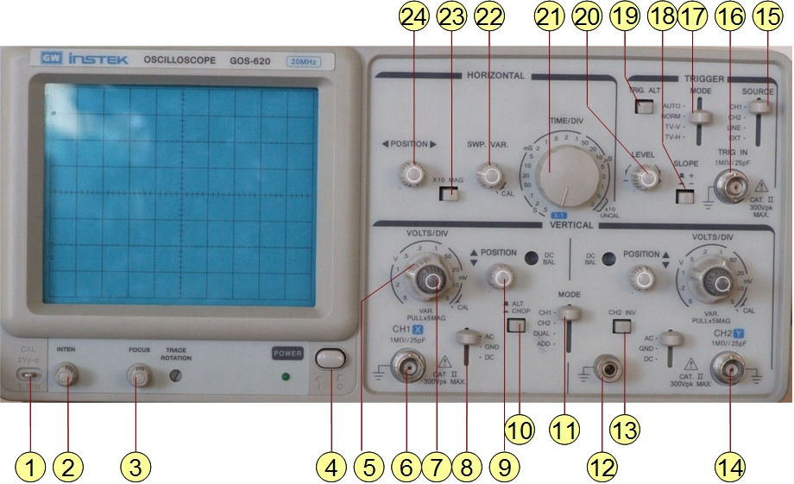
Fig. 4. The panel of type GOS-20 Oscilloscope
The functions of some knobs and switched on the panel are not introduced here. For a fully detailed description of all the knob and switches, please refer to the corresponding manual of this Oscilloscope.
- Initialization and operation
- To facilitate the operation, before turning on the power, initialization of the GOS – 20 is needed. The initializing steps listed in table 1 should be strictly followed.

Table 1. The initial values suggested for the Knobs and switches
Knobs & No. |  | Settings | Knobs & No. |  | Settings
POWER | 4 | OFF | AC-GND-DC | 8 | GND
INTEN | 2 | Middle | SOURCE | 15 | CH1
FOCUS | 3 | Middle | SLOPE | 18 | +SLOPE
VERTMODE | 11 | CH1 | TRIG.ALT | 19 | Raised
ALT/CHOP | 10 | ALT | TRIGGER MODE | 17 | AUTO
CH2 INV | 13 | Raised | TIME/DIV | 21 | 0.5ms/div
POSITION (up and down) | 9 | Middle | SWP.VAR | 22 | At CAL
VOLTS/DIV | 5 | 0.5V/div | POSITION (left and right) | 24 | Middle
VARIABLE | 7 | At CAL | × 10MAG | 23 | Raised

- After properly setting the oscilloscope, a trace should be observed on screen after turning on the power.
- Adjusting proper focus and brightness by knob 2 and 3.
- Performing the measurements by adjusting corresponding knobs and switches properly.

Purpose
- Get familiar with oscilloscope and its applications. Understand the principle an oscilloscope displays signal waveform, as well as the concepts of synchronization, scanning, and triggering.
- Learn how to adjust an oscilloscope. Learn the methods for observing signal waveform and measuring signal voltage. Understand the principle of the Lissajous figures and master the methods to measure signal frequency.
Equipments
GOS-620 Oscilloscope, public and private signal generators (PG1 and PG2 thereafter), BNC wires.
Exercises
- Observe the waveform:
Turn on the power and adjust the “INTEN” and “FOCUS” knobs to keep the scanning trace in proper brightness, thickness, and focusing. Illustrate the functions of knobs “POSITION (horizontal)”, “POSITION (vertical)”, and “TRI. LEVEL”, respectively. Connect PG2 to either of the two inputs and observe the patterns from sine wave, triangle wave, square wave, and signals with different frequencies.
- Measure the voltage and frequency of electrical signals
Measure the peak-peak values of the voltage and calculate corresponding effective values. For a better accuracy, three rounds measuring are required under different voltage sensitivities.
Stalls | Divisions | Peak-peak values | Effective values
/DIV
/DIV
/DIV

Stalls | Divisions | Period | frequency
/DIV
/DIV
/DIV

- Measure the frequency using Lissajous figures
Set the Oscilloscope in X-Y plotting mode. Connect public and private signal generators (PG1 and PG2) to vertical and horizontal inputs respectively, try to get the Lissajous figures. Change the frequency of PG2 and observe the change of the figure patterns. Measure the frequencies of PG1 (f_{PG1}) in frequency proportions (f_{PG2}:f_{PG1}) of 1:1, 1:2, 2:1, and 3:2. Record the data for further calculation.
f_{PG2}:f_{PG1} | f_{PG2} (Hz) | Figure patterns | f_{PG1}(Hz)
1:1
1:2
2:1
3:2

Questions
- Why do we choose a well-profiled sawtooth waveform for the scanning voltage (U(x))?
- What determines the bandwidth of an oscilloscope?
- What factors can affect the accuracy of oscilloscope measurements?
References
- 成正维，牛原 主编，《大学物理实验》，北京交通大学出版社，2010
- Lab Courses, the Department of Electrical and Computer Engineering, University of Waterloo, Canada
- Laboratory Manual, Department of Physics, University of Maryland, USA

